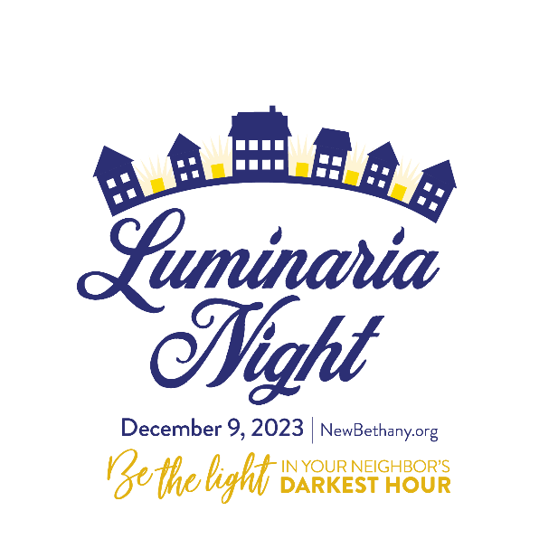

The 26th Annual Luminaria Night will take place on December 9, 2023. Luminaria Night is a beautiful and enchanted evening when all the homes in our neighborhood line the streets with luminaria – white paper bags with lit candles.

All Luminaria Night proceeds benefit New Bethany in Bethlehem. Since 1985, New Bethany has impacted over 140,000 lives by offering hope and support to people who experience poverty, food insecurity, and homelessness.

Please join me in being the light in our neighbor’s darkest hour. That neighbor may be searching for a warm bed tonight or a hot meal.

Together, let’s illuminate our beautiful neighborhood and make a real difference.

To get involved,
scan this QR code: Your Block Captain Is:
Name
Address
Phone Number
Email
Fundrazr Link

